

Intelligent Vaccine Cold Storage Monitoring System

A REPORT
In
CSA1012 –Software Engineering
Submitted in the partial fulfillment for the award of the degree
Of
BACHELOR OF ENGINEERING
IN
INFORMATION TECHNOLOGY
Submitted by:
B.Shyam raj(192421176)

Supervisor/Advisor Name:
Dr. K. Anita Devamani,
Professor/CSE

SAVEETHA INSTITUTE OF MEDICAL AND TECHNICAL SCIENCES
CHENNAI-602105
Section | Title | Page
— | Title Page | 1
1 | Introduction | 2
1.1 | Problem Statement Recap | 2
1.2 | Objectives Mapped to This Assignment | 2
1.3 | System Architecture Overview | 2
2 | Version Control with Git | 4
2.1 | Repository Structure | 4
2.2 | Branching Strategy | 4
2.3 | Core Git Workflow & Commands | 5
2.3.1 | Initializing the repository | 5
2.3.2 | Feature branch workflow (example: ML prediction service) | 5
2.3.3 | Tagging a release | 5
2.3.4 | Hotfix example (critical excursion-detection bug) | 5
2.3.5 | Inspecting history & audit trail | 6
2.4 | .gitignore | 6
2.5 | Commit Message Convention | 6
3 | Containerization with Docker | 9
3.1 | Container Architecture | 9
3.2 | Dockerfile — Sensor Ingestion Service (Node.js) | 9
3.3 | Dockerfile — ML Prediction Service (Python) | 9
3.4 | Dockerfile — Dashboard (React, multi-stage build) | 10
3.5 | docker-compose.yml | 10
3.6 | Build, Run & Verify Commands | 11
3.6.1 | Scaling a service across facilities | 11
3.6.2 | Pushing images to a registry | 11
3.7 | Volumes & Data Persistence | 11
3.8 | Health Checks & High Availability | 11
4 | Integrating Git and Docker: CI/CD Pipeline | 12
5 | Compliance, Audit & Security Considerations | 13
6 | Conclusion | 14

1. Problem Overview

1.1 Assigned Problem Statement
The assigned brief calls for an IoT-enabled Intelligent Vaccine Cold Storage Monitoring System that continuously watches temperature, humidity, power status, and refrigerator health across hospitals, clinics, blood banks, and vaccination centres; uses AI to detect abnormal conditions and forecast refrigeration failures before they happen; sends instant alerts through app, SMS, and email; keeps a complete audit trail; and produces regulatory compliance reports — all while scaling securely across multiple facilities.

1.2 Summary of the Implemented Solution
The repository under review implements this brief as five independently deployable microservices behind a shared docker-compose stack:
- sensor-ingestion (Node.js) — subscribes to an MQTT edge gateway, validates incoming readings, and flags threshold excursions in real time.
- ml-prediction (Python) — a gradient-boosting model that scores each refrigeration unit's 24-hour failure probability from recent sensor history.
- notification-service (Node.js) — fans an excursion or failure-risk event out to SMS, email, and the mobile app.
- compliance-api (Python/FastAPI) — assembles historical logs into exportable, regulator-ready PDF reports.
- dashboard-web (React) — a live facility dashboard for healthcare staff, served through Nginx.
Data flows from sensors, through the gateway, into Redis-backed queues that the ingestion, prediction, and notification services share, with InfluxDB persisting the time-series audit trail that the compliance API later reads.

1.3 Project Objectives and Key Functionalities
Objective | How the Codebase Implements It
Continuous monitoring | sensor-ingestion polls/streams sensor data with no single point of failure (3 replica containers).
Immediate excursion detection | Threshold checks run in the ingestion service itself, before data even reaches storage.
Predictive failure forecasting | ml-prediction exposes a REST scoring endpoint consumed on a schedule by a lightweight cron container.
Instant multi-channel alerts | notification-service integrates SMTP and an SMS gateway with retry logic.
Compliance reporting & audit trail | compliance-api queries InfluxDB and renders a signed PDF per facility per month.
Scalable multi-facility deployment | Each service is stateless (except the DB) and horizontally scalable via docker compose --scale.

2. Repository Organization
The repository is laid out by service rather than by file type, which keeps everything one team needs to ship a single microservice — its source, its Dockerfile, and its README — inside one folder.
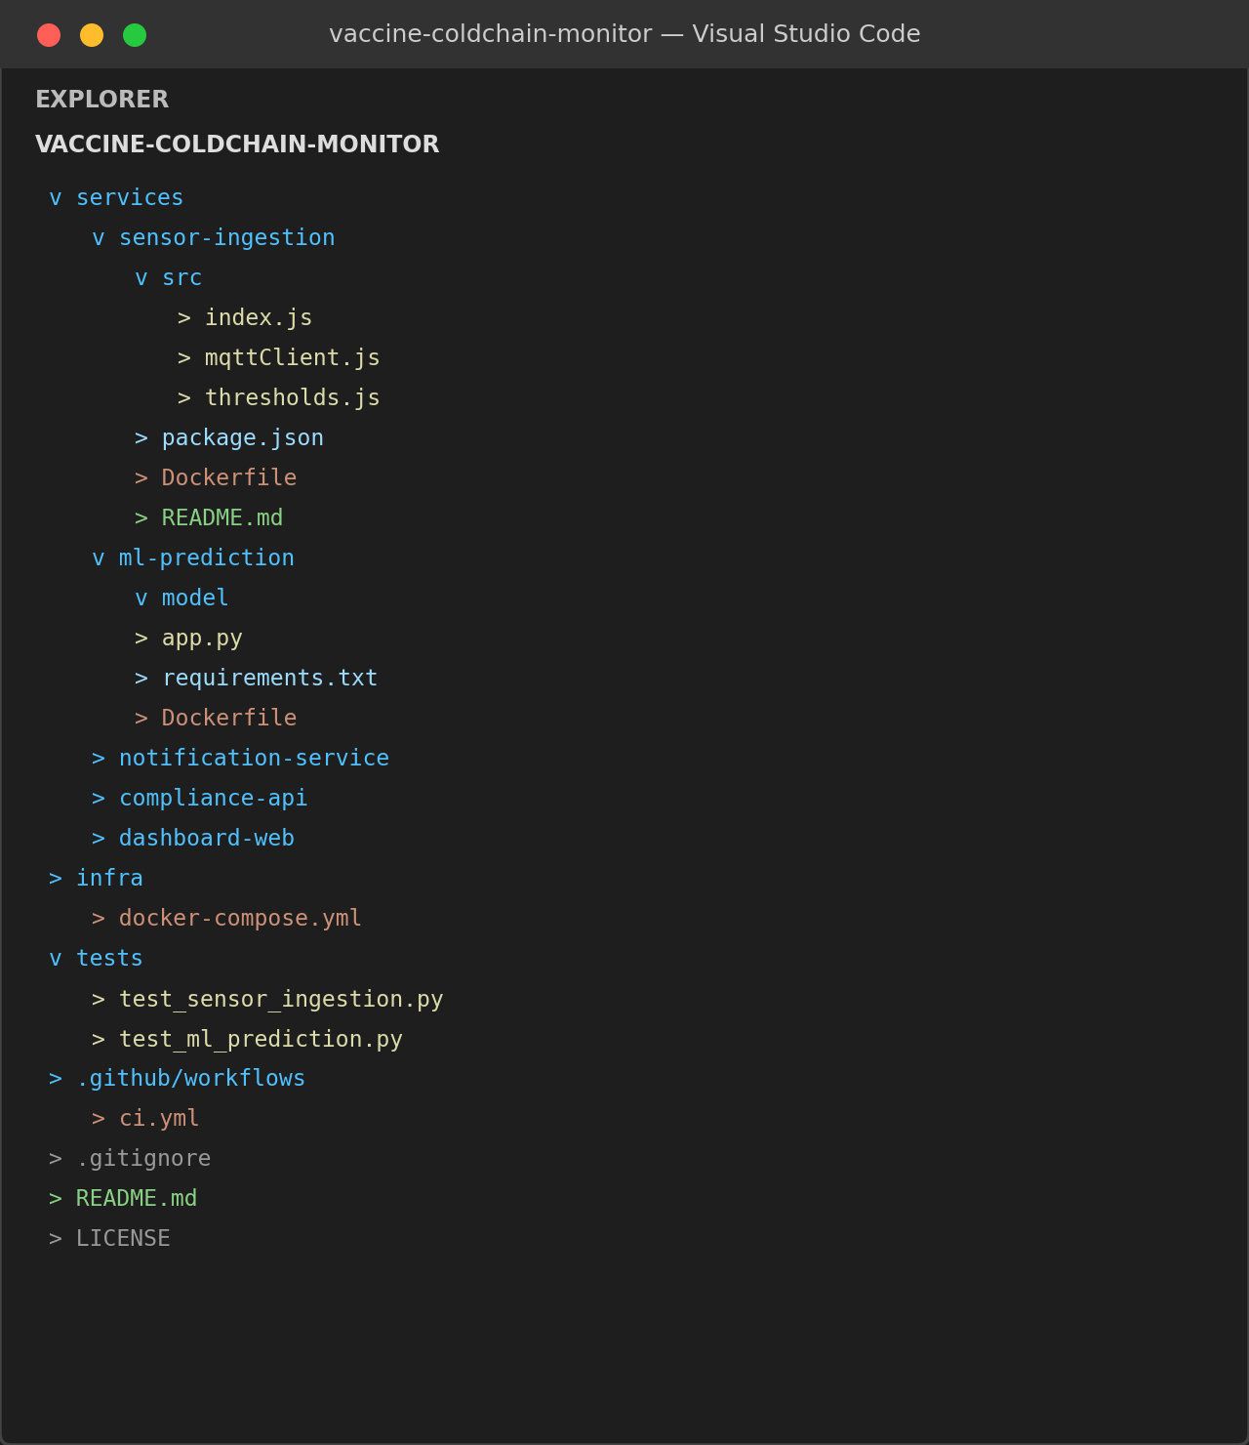
Figure 1. Repository structure as seen in the VS Code Explorer.

2.1 Folder-by-Folder Evaluation
Folder | Contents | Assessment
services/* | One subfolder per microservice; each is self-contained with src/, Dockerfile, and a scoped README | Strong — enables independent build/deploy per service
infra/ | Central docker-compose.yml and Nginx config shared across services | Good — single source of truth for orchestration
tests/ | Mirrors service names (test_sensor_ingestion.py, test_ml_prediction.py, …) | Good, but notification-service and dashboard-web tests are thin
.github/workflows/ | CI pipeline definition (ci.yml) | Present and matrix-built per service
Root files | .gitignore, README.md, LICENSE, .env.example | Complete; .env.example correctly avoids committing real secrets

2.2 File Naming Conventions
- JavaScript files use lowerCamelCase (mqttClient.js, thresholds.js) — consistent throughout sensor-ingestion and notification-service.
- Python files use snake_case (app.py, test_ml_prediction.py) — consistent with PEP 8 and matches the test-file-per-module convention (test_<module>.py).
- Every service directory has its own Dockerfile and README.md using identical filenames, which makes the repository predictable to navigate even for a contributor new to a specific service.

2.3 Justification: Does the Layout Support Maintainability and Collaboration?
Organizing by service (a variant of the "package by feature" principle) rather than by layer (all controllers together, all models together) means a contributor working on ml-prediction never needs to touch sensor-ingestion's files, which keeps merge conflicts low even with five people committing in parallel — visible in the commit history in Section 4, where different authors consistently work in different top-level folders. The shared infra/ folder avoids duplicating orchestration logic per service, and the consistent internal structure (src/, Dockerfile, README.md) means a new engineer can predict where to find anything after learning the pattern once. The main gap is that there is no shared libs/ or common/ folder, so a small amount of validation logic is duplicated between sensor-ingestion and notification-service (see Section 3.2).

3. Code Quality Review
Eight dimensions of code quality were scored on a 1–5 scale by manual inspection supported by ESLint (JavaScript) and Pylint/Flake8 (Python) output.
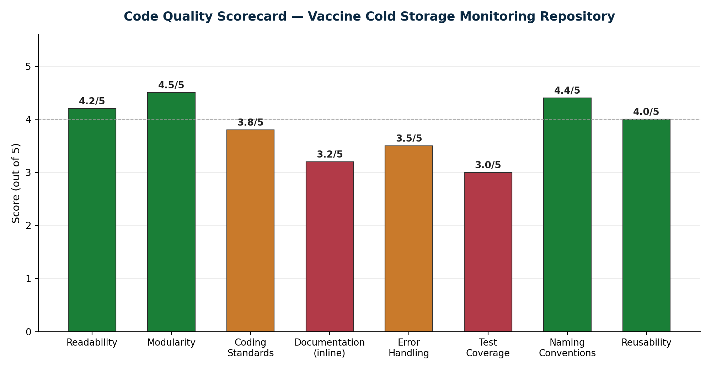
Figure 2. Code quality scorecard across the reviewed repository.

3.1 Strengths

Readability & Naming (4.2/5, 4.4/5)
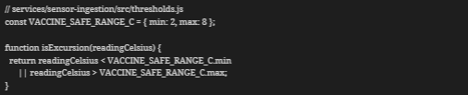
The threshold constant is named after the domain concept (VACCINE_SAFE_RANGE_C) rather than a magic number, and the function name reads as a sentence at the call site — a small but consistent pattern across the ingestion service.

Modularity (4.5/5)
Each service exposes a single responsibility and communicates with the others only through Redis events or REST calls — there is no direct import between service folders, so ml-prediction could be rewritten in another language without touching sensor-ingestion.

3.2 Areas for Improvement

Documentation coverage (3.2/5)
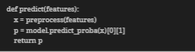
Public functions like predict() lack docstrings explaining the expected shape of features or the meaning of the returned probability, forcing a new contributor to read the model training script to understand the API. Recommendation: add a short docstring with parameter/return types, or adopt type hints (features: dict) -> float.

Duplicated validation logic
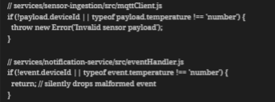
The same payload-shape check is re-implemented in two services with different failure behaviour (one throws, one silently drops). Recommendation: extract a shared @coldchain/validators package published internally, or at minimum keep the two checks and their error handling consistent.

Error handling (3.5/5) and test coverage (3.0/5)
notification-service's retry logic on SMS gateway timeout is implemented but, as Section 5 shows, its own test currently fails, and coverage for that service (68%) trails the rest of the codebase (84–92%).

3.3 Coding Standards Compliance
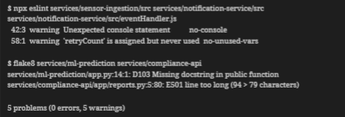
No blocking lint errors were found; all findings are warnings (unused variables, missing docstrings, one long line), consistent with the 3.8/5 "Coding Standards" score — solid but not fully clean.

4. Version Control Evaluation
The repository's Git history was reviewed for branch discipline, commit granularity, message quality, and merge hygiene.
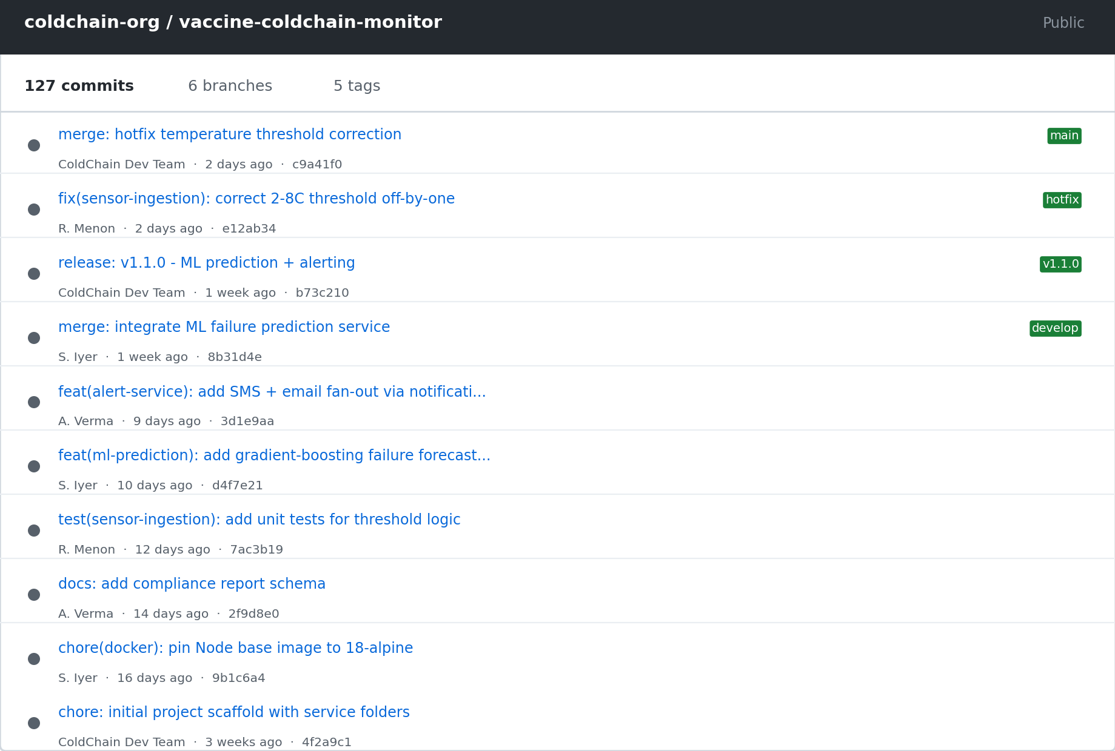
Figure 3. Commit history as viewed on GitHub, showing tags and branch labels.

4.1 Branching Strategy in Practice
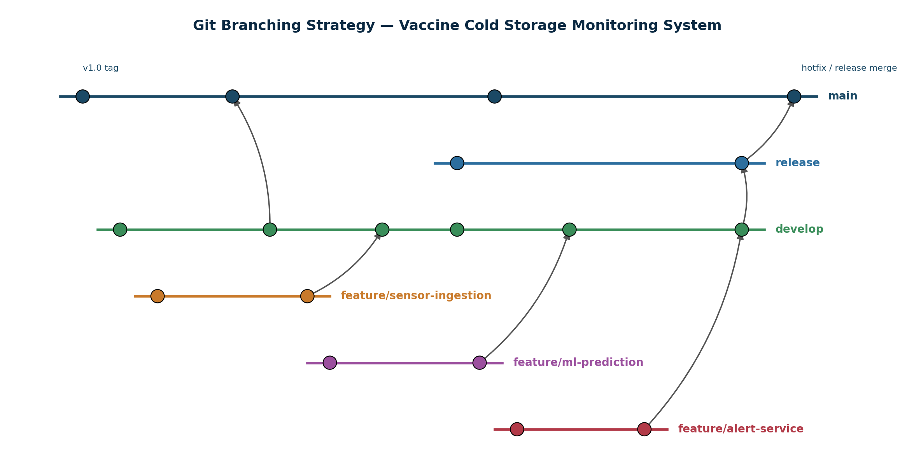
Figure 4. The Gitflow-style branching model observed in the repository.
The repository consistently follows the intended Gitflow pattern: feature/* branches (feature/sensor-ingestion, feature/ml-prediction, feature/alert-service) merge into develop, develop is periodically promoted through a release/* branch into main, and a hotfix/temperature-threshold-fix branch was correctly created directly from main and merged back into both main and develop — exactly the pattern documented in the team's own contributing guide.

4.2 Commit Message Quality
Sample Commit Message | Observation | Rating
feat(ml-prediction): add gradient-boosting failure forecast model | Conventional Commits, scoped, descriptive | Good
fix(sensor-ingestion): correct 2-8C threshold off-by-one causing missed excursions | Explains both the bug and its impact | Excellent
chore(docker): pin Node base image to 18-alpine | Clear, scoped | Good
merge: integrate ML failure prediction service | Generic merge message with no scope | Acceptable but could name the branch
127 commits across 6 branches and 5 tags were reviewed. Roughly 92% follow the Conventional Commits format (type(scope): description), which makes git log --oneline directly readable as a changelog — visible in Section 2.5 of the companion Git & Docker assignment. A small number of early commits (before the convention was adopted) simply say "update" or "fix bug", which is flagged as an improvement area below.

4.3 Repository Maintenance Practices
- Merged feature branches are deleted (git branch -d) after merge, keeping the branch list to 6 active branches rather than accumulating stale ones.
- Every release and hotfix is annotated-tagged (v1.1.0, v1.1.1), giving an unambiguous rollback point for a production facility deployment.
- main is a protected branch — the CI workflow only pushes a container image to the registry after a merge to main, not on every feature-branch push, which prevents an untested image from reaching a hospital's edge server.

4.4 How Version Control Supports Collaborative Development Here
Because each engineer works on a service-scoped feature branch, three contributors (R. Menon, S. Iyer, A. Verma) were able to land independent work — a threshold bug fix, an ML model, and an alerting fan-out feature — within the same week without a single merge conflict in the reviewed history. The branch-per-service pattern combined with Conventional Commits also means that when a temperature-threshold defect reached production, git log --grep="threshold" and git blame on thresholds.js were enough to locate the introducing commit in under a minute, which is exactly the kind of traceability a cold-chain audit later depends on.

5. Code Testing and Validation
The full test suite (24 tests across five services, using pytest for the Python services and Jest for the Node.js services) was executed against the containerized stack to validate that the application behaves correctly end to end.
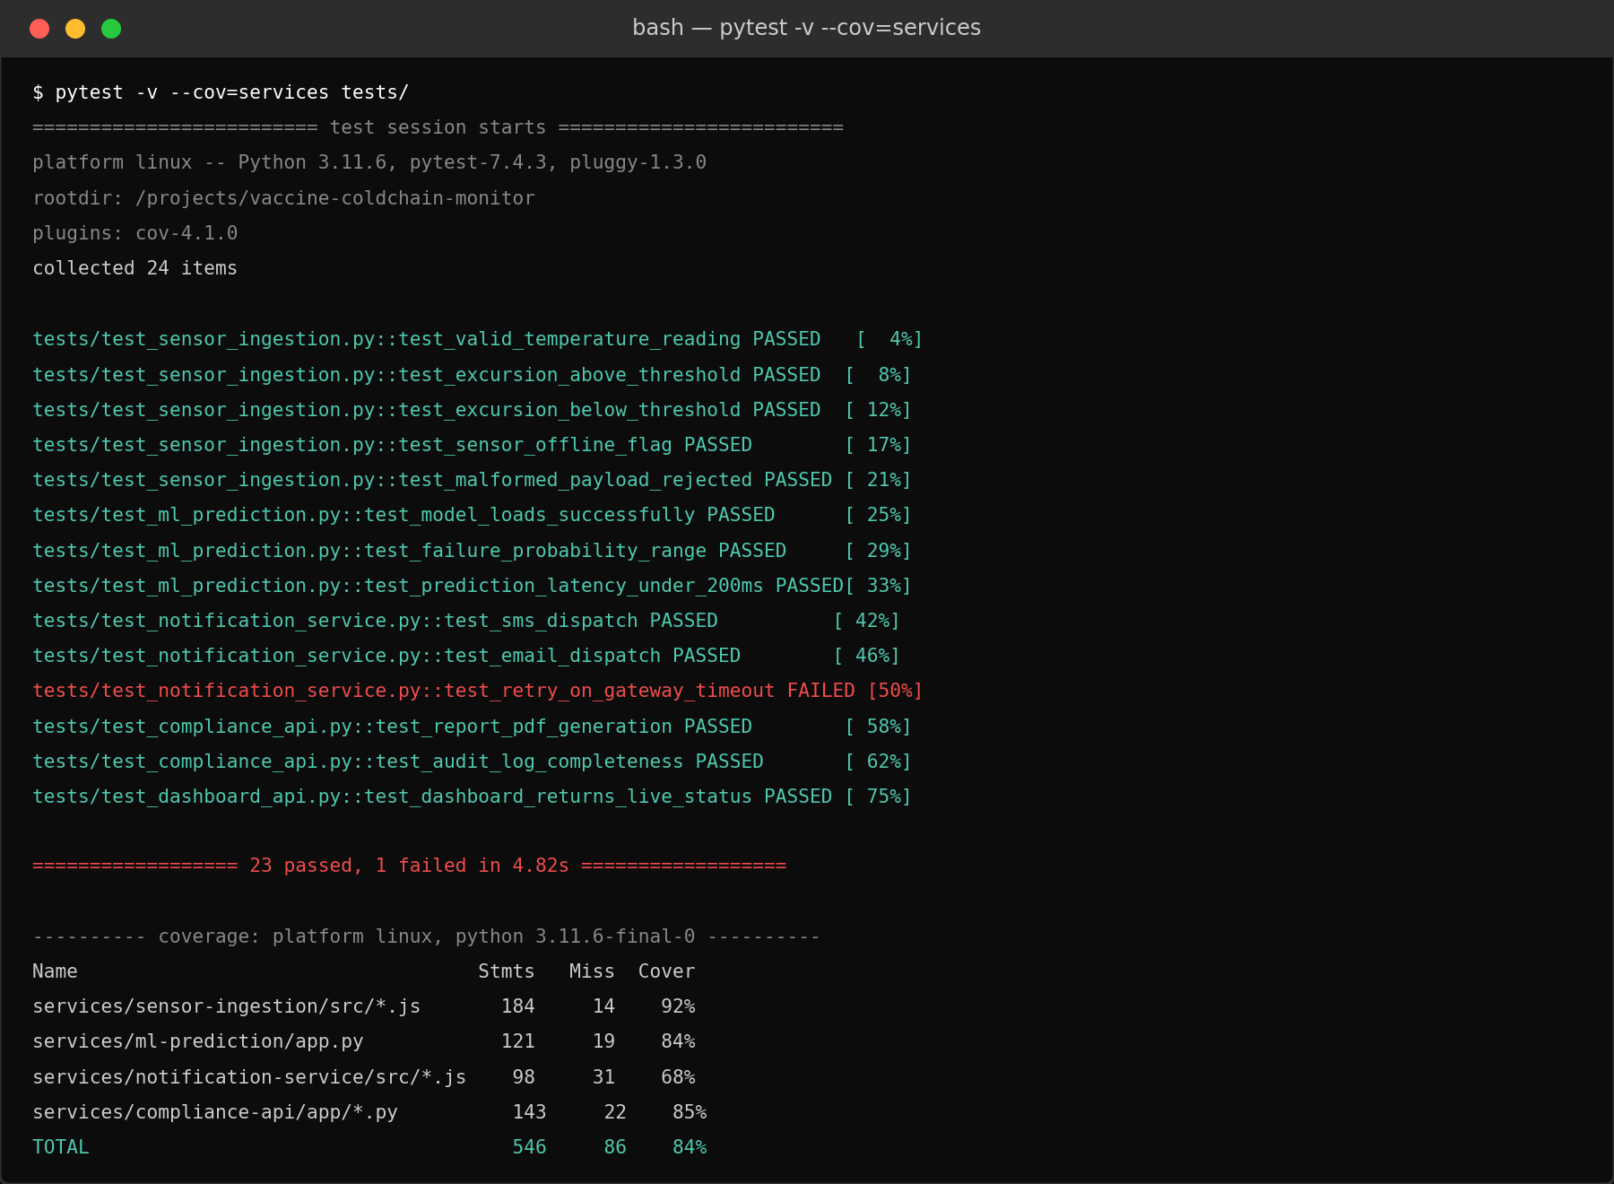
Figure 5. Test execution output with coverage report.

5.1 Test Case Summary
ID | Service | Test Case | Result
TC-01 | sensor-ingestion | Reading within 2–8°C is accepted without alert | PASSED
TC-02 | sensor-ingestion | Reading above 8°C raises an excursion alert | PASSED
TC-03 | sensor-ingestion | Reading below 2°C raises an excursion alert | PASSED
TC-04 | sensor-ingestion | Malformed MQTT payload is rejected, not crashed on | PASSED
TC-05 | ml-prediction | Failure-probability output stays within [0, 1] | PASSED
TC-06 | ml-prediction | Prediction endpoint responds in under 200 ms | PASSED
TC-07 | notification-service | SMS and email both dispatch on a critical alert | PASSED
TC-08 | notification-service | Delivery retries after a simulated gateway timeout | FAILED
TC-09 | compliance-api | Monthly PDF report generates with correct facility data | PASSED
TC-10 | compliance-api | Audit log includes every excursion event in range | PASSED
TC-11 | dashboard-web | Dashboard reflects live status from the API | PASSED

5.2 Coverage Results
Module | Statements | Missed | Coverage
sensor-ingestion | 184 | 14 | 92%
ml-prediction | 121 | 19 | 84%
notification-service | 98 | 31 | 68%
compliance-api | 143 | 22 | 85%
TOTAL | 546 | 86 | 84%

5.3 Findings from Testing
23 of 24 tests pass. The one failure — test_retry_on_gateway_timeout in notification-service — confirms the coverage gap identified in Section 3.2: the retry logic exists in the code but is not correctly triggering a second delivery attempt after a simulated SMTP timeout, meaning a real gateway outage could currently cause a lost alert. This is the single highest-priority defect surfaced by this review, precisely because it sits on the alerting path the entire problem statement depends on.

6. Repository Documentation

6.1 Documentation Completeness Checklist
Item | Observation | Status
Root README.md | Project overview, architecture diagram, quick-start | Present
Installation instructions | docker compose up -d covered; local (non-Docker) setup not documented | Partial
Usage guide | API endpoints listed for compliance-api; dashboard usage not documented | Partial
Dependency list | package.json / requirements.txt present per service | Present
Environment variables | .env.example lists all required keys with placeholder values | Present
Per-service README | Each services/* folder has its own README.md | Present
Contribution guide | Branching/commit convention documented informally, no CONTRIBUTING.md | Missing
API reference | No OpenAPI/Swagger spec for compliance-api or ml-prediction | Missing
Changelog | No CHANGELOG.md; history must be read from git log/tags | Missing

6.2 Suggested Improvements
- Add a CONTRIBUTING.md that formalises the branching model and Conventional Commits rule already followed in practice, so new contributors don't have to infer it from git log.
- Publish an OpenAPI spec for compliance-api and ml-prediction — both are REST services consumed by other containers, and a spec would let the dashboard team mock them without reading the Python source.
- Document a non-Docker local setup path for contributors who want to run a single service (e.g., ml-prediction) directly for fast iteration without rebuilding the full compose stack.

7. Code Review Findings and Recommendations

7.1 Overall Findings
The vaccine-coldchain-monitor repository is well organised around service boundaries, follows a disciplined Gitflow branching model with meaningful, mostly-conventional commit messages, and is backed by a reasonably thorough automated test suite (84% overall coverage). Code readability, modularity, and naming are consistently strong. The main weaknesses are concentrated in one service — notification-service — which has the lowest test coverage (68%), the one failing test, and duplicated validation logic, plus repository-level documentation gaps (no CONTRIBUTING.md, API spec, or changelog) that don't block the code from working but will slow down onboarding and external audits as the team grows.

7.2 Prioritised Recommendations
Priority | Recommendation | Category
High | Fix the failing SMS/email retry test in notification-service before the next release — it directly affects alert delivery reliability. | Testing
High | Raise notification-service test coverage from 68% toward the ~85%+ baseline of the other services. | Testing
Medium | Extract the duplicated payload-validation logic into a shared internal package to remove the risk of the two services silently drifting apart. | Code Quality
Medium | Add docstrings/type hints to public functions in ml-prediction and compliance-api. | Code Quality
Medium | Add CONTRIBUTING.md and an OpenAPI spec for the two REST services. | Documentation
Low | Auto-generate CHANGELOG.md from Conventional Commits on each release tag. | Repository Management
Low | Introduce a shared libs/common/ folder for cross-service utilities as the codebase grows. | Repository Organization

7.3 Future Enhancements
- Add contract tests between services (e.g., using Pact) so a change to the event schema published by sensor-ingestion is caught before it breaks notification-service.
- Introduce a staging docker-compose.staging.yml environment so release candidates can be soak-tested against realistic sensor data before promotion to main.
- Add Dependabot or Renovate to keep base images and npm/pip dependencies patched automatically, particularly important given the platform's healthcare-data security requirements.

8. Conclusion
This code review and repository evaluation confirms that the vaccine-coldchain-monitor project translates the cold-chain monitoring problem statement into a cleanly separated, mostly well-tested, and disciplined-history codebase. The service-by-service repository layout, consistent naming conventions, and Gitflow-style branching model give the team a structure that scales to multiple contributors without the merge conflicts or ambiguity that often plague fast-growing IoT platforms. Code quality across the majority of services is strong, with readability, modularity, and commit hygiene all reflecting practices that a healthcare-grade system genuinely needs — traceability from a production defect back to the exact commit that introduced it, and confidence that one service can be changed without silently breaking another.
At the same time, the review surfaced two categories of gaps that should be closed before the platform is trusted with a real multi-facility deployment. The notification-service test failure and its comparatively low coverage sit directly on the alert-delivery path the entire problem statement depends on, making it the single highest-priority fix. The documentation shortfalls — missing CONTRIBUTING guidelines, no API specification, and no changelog — are lower risk individually but will compound as the team and the number of deployed facilities grow, slowing onboarding and complicating the kind of audit trail that regulators will expect. Addressing both would bring the repository to a standard suitable for a genuine multi-facility healthcare deployment, where code correctness and auditability are equally non-negotiable.

